Python Classes/Objects

Python is an object oriented programming language.

Almost everything in Python is an object, with its properties and methods.

A Class is like an object constructor, or a "blueprint" for creating objects.

## Create a Class

To create a class, use the keyword class:

**Syntax:**Class Definition

class ClassName:  
 # Statement

Example:-

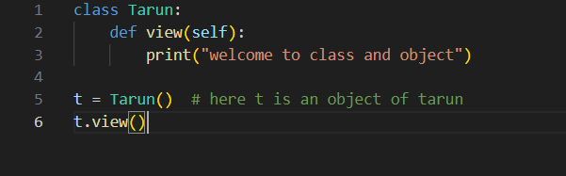

Output:-

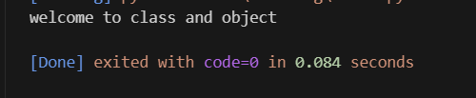

Create Object

Now we can use the class named MyClass to create objects:

**Syntax:**Object Definition

obj = ClassName()  
print(obj.atrr)

Example:-



Output:-

